Northern Section NVASLA April Newsletter 2019
By Barb Santner PLA, Senior Landscape Architect/Planner with Stantec
Reno Low Impact Development Tour

On Thursday, March 21, 2019, a group of 13 from the Northern Section of NVASLA convened in downtown Reno at The Depot for a tour of low impact development projects in Reno. Low impact development (LID), as defined by the Environmental Protection Agency, is an approach to land (re)development that works with nature to manage stormwater as close to its source as possible. LID typically includes site design strategies to direct stormwater from impervious areas to pervious areas such as landscape buffers and islands where storm water can infiltrate into the ground. Our group hosted this program because of increasing requirements to include LID design features in projects by the City of Reno and because of overall interest in green infrastructure.
Our first stop was the Evans Warehouse, where Barb Santner informed the group about the LID design features. Storm water is captured from roof down drains which flow into a landscaped bioswale sized to accept small and large storm events. Storm water in parkways and landscaped bioswales also infiltrate into sand based structural soils (SBSS) that is beneath all sidewalks. Swales drain to a corner rain garden which fills and drains to a beehive storm drain structure. Overflow from the basin/beehive drain flows into an underground Stormtech Chamber System where excess runoff is detained and sediments settle. A manhole allows for inspection and removal of sediment. The rain garden is landscaped with ornamental grasses, perennials, shrubs and trees to use the storm water. Close collaboration between the project civil engineer and landscape architects were required to successfully design this project.
Our next stop was at the McKinley Arts and Culture Center where landscape architect Dan Kovach PLA/Atkins provided the tour. Roof drainage is captured in swales and directed to a rain garden. Due to concern about water in swales damaging the building foundation, these swales are armored with concrete with river cobble rock embedded into the side slopes to slow water and cause sediment to drop out before entering the raingarden. The landscaped raingarden was placed between mature trees and designed with subsurface aggregate base material to allow for high levels of infiltration. Interpretive signs were placed nearby to explain the LID design approach to visitors. Another aspect of the McKinley Center site is a parking lot built to demonstrate pervious concrete. The parking lot captures roof drainage from the opposite side of the building as the rain garden. The pervious concrete requires regular cleaning to remove sediment. Even though the infiltration is reduced since the initial installation it still drains approximately 34 inches per hour.
The last project we visited was the Cabela’s retail store on I-80 in west Reno. Our tour was provided by Kreg Mebust PLA, landscape architect and design instructor at TMCC. This project is one of the largest LID projects in Northern Nevada. Kreg explained the strategy to direct parking lot storm water into landscaped islands through curb cuts. All landscaped parking lot islands were designed as a series of basins which store and infiltrate small storm events. Overflow leaves islands at low points through curb cuts. Remaining storm water flows to a large exterior detention basin, placed around the entire parking lot exterior and a portion of the building. It functions as a buffer between the primary access roadway and is landscaped with native and regionally adapted grasses, perennials, shrubs and trees. The project is over 15 years old and has generally held up well. Kreg stressed the collaboration between the project civil engineer and landscape architect as crucial to successful design.
After this inspiring tour, a smaller, dedicated group made it back to The Depot brew pub where Ellis from NSBLA joined them for drinks and refreshments.

At Evans Warehouse in Downtown Reno
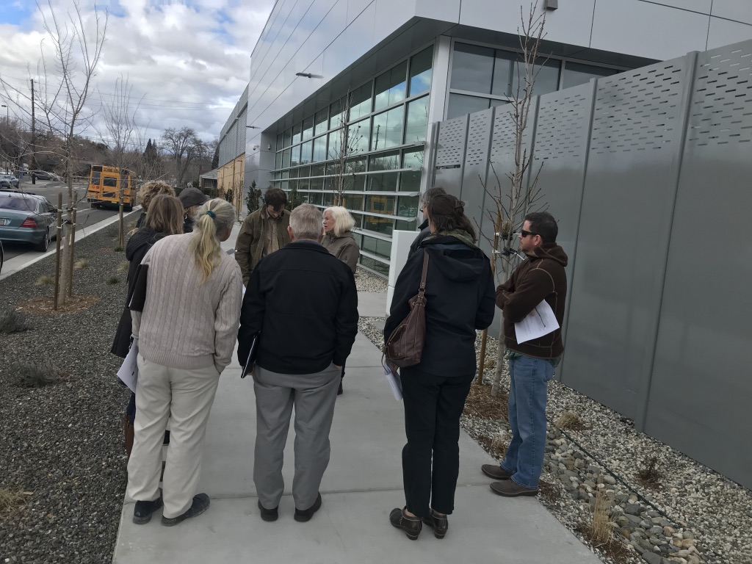
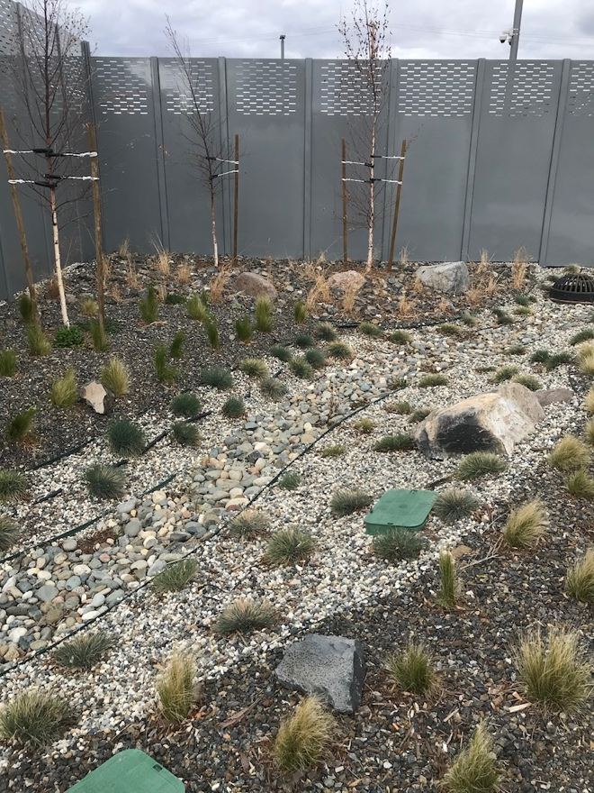
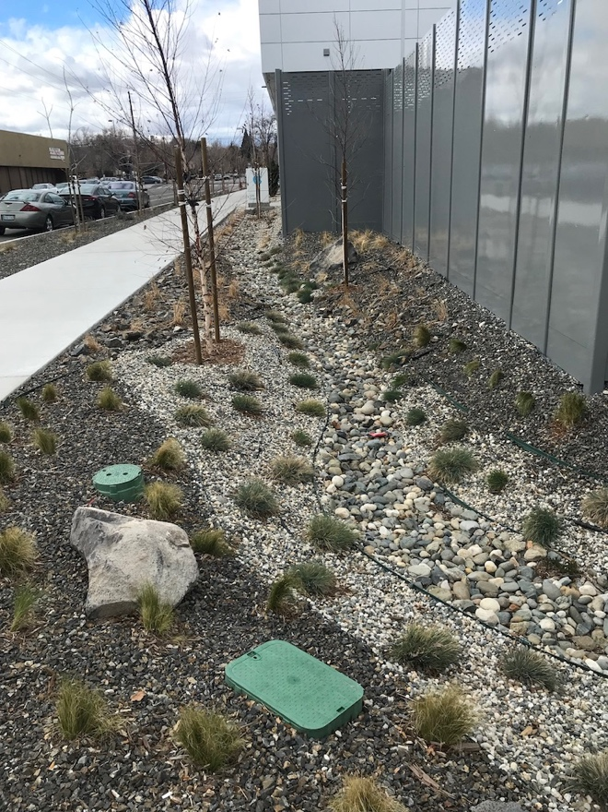
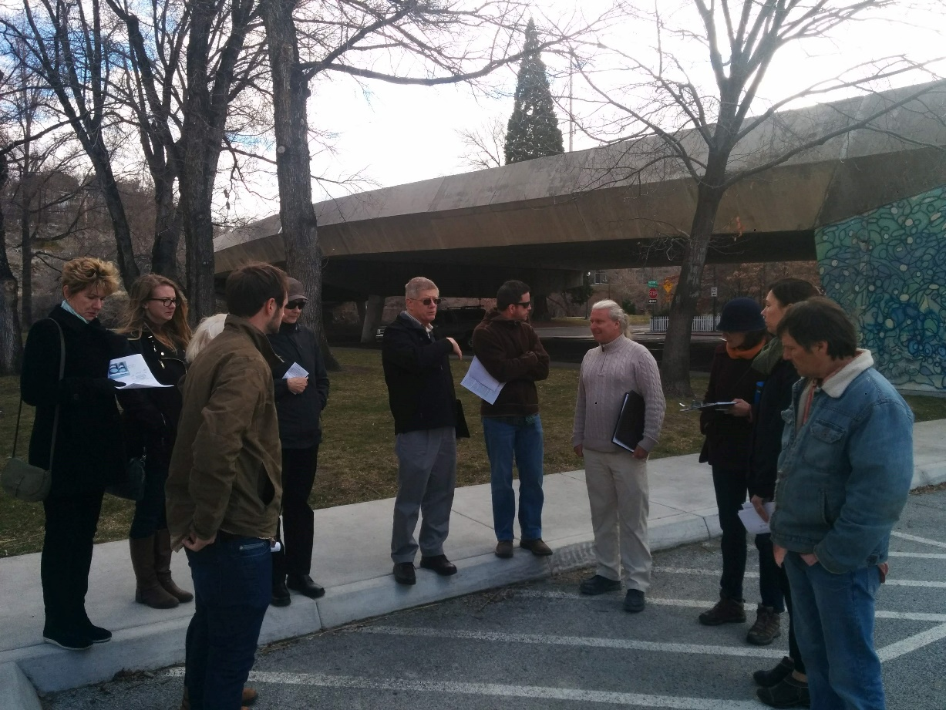
At McKinley Arts and Culture Center pervious concrete parking lot and raingarden

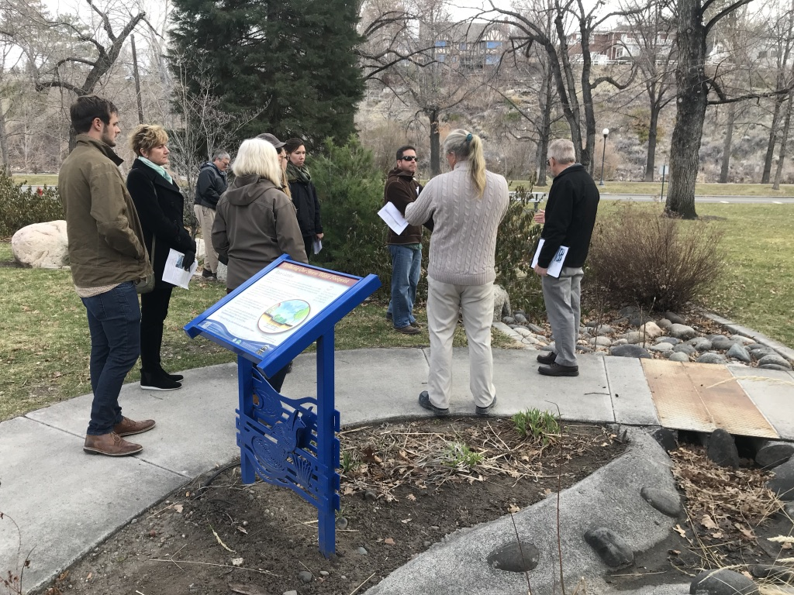

At Cabela’s infiltration parking lot islands with overflow to large retention planting area
